Virginia Occupational Safety and Health (VOSH) State Plan Formal Response to FY 2025 Comprehensive FAME Report


James S. Frederick
COMMISSIONER

October 1, 2026

COMMONWEALTH of VIRGINIA

DEPARTMENT OF LABOR AND INDUSTRY

Brookfield Place 6606 West Broad Street, Suite 500
Richmond, Virginia 23230
PHONE (804) 371-2327
FAX (804) 371-6524

Michael Rivera Regional Administrator
Occupational Safety and Health Administration 1835 Market Street
Philadelphia, PA 19103-2968

SUBJECT: Virginia FY 2025 Comprehensive Federal Annual Monitoring and Evaluation (FAME) Report

Dear Mr. Rivera:

Thank you for your letter of September 24, 2026, forwarding Virginia's FY 2025 Comprehensive Federal Annual and Evaluation (FAME) Report for the Virginia Occupational Safety and Health (VOSH) program. I am pleased that the FY 2025 evaluation identified no continuing findings or observations from prior evaluations and no new findings for this fiscal year. With respect to the observation noted in the report, VOSH will continue to monitor case files to ensure that next-of-kin letters are issued as appropriate.

This positive outcome reflects VOSH's continued commitment to effective program administration and continuous improvement. We appreciate the constructive input and feedback provided by the OSHA evaluation team and value our ongoing cooperative and mutually supportive relationship with the Regional Office.

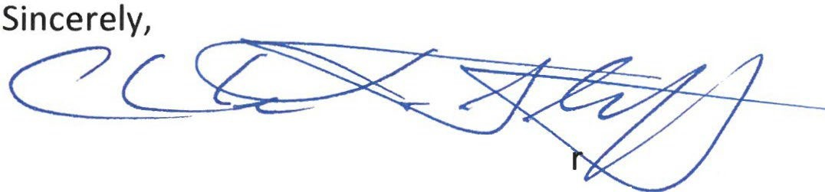
Charles L. Stiff, Deputy Commissioner -
Virginia Department of Labor and Industry

