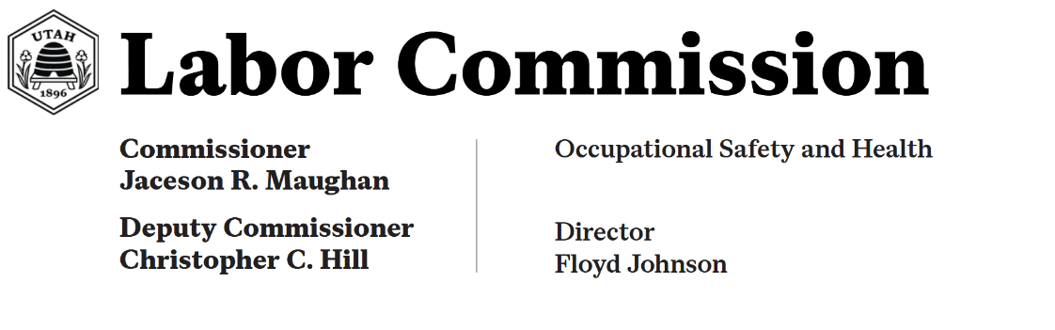

October 14, 2026 Ms. Billie Kizer
Acting Regional Administrator
U.S. DOL - OSHA, Denver Region

Re: Response of the Utah Occupational Safety and Health Division to the FY 2025 Federal Annual Monitoring and Evaluation (FAME) Report

Dear Ms. Kizer,

Thank you for the opportunity to participate in the FY 2025 FAME of the Utah Occupational Safety and Health (UOSH) Division of the Utah Labor Commission. It is a pleasure working with you and your staff, and UOSH looks forward to continuing to build a mutually beneficial relationship with the Denver Region. This letter will serve as UOSH’s formal response to the specific observations set forth in the FY 2025 FAME.

UOSH continues its efforts to work effectively and consistently and to pursue its mission to help ensure a safe and healthy workplace for every worker in the State of Utah.

UOSH is committed to carefully prioritizing its ongoing operational functions. Additionally, UOSH is committed to addressing the new and continued observations presented in this FAME audit and believes that many, if not all, will be closed in the FY 2026 Follow-up FAME.

UOSH responds specifically as follows to the Observations presented in the FY 2024 Follow-up FAME:

Observation FY 2025-OB-01 (previously FY 2024-OB-03, FY 2023-OB-04): In FY 2025, 38 of 49 (77.55%) case files contained violation worksheets with inadequate evidence of employer knowledge. UOSH did not follow the guidance in Chapter 5, Section II.C.2.i and Chapter 4, Section II.C.4 of the UOSH FOM.

UOSH Response:
UOSH notes the continued observation regarding inadequate documentation of employer knowledge in violation worksheets. In response, UOSH has and will continue to conduct training for all staff members centered on the evidentiary requirements outlined in Chapters 4 and 5 of the FOM. Additionally, UOSH has created field guides in the form of checklists that CSHOs can reference during an inspection to ensure adequate evidence is documented.

Observation FY 2025-OB-02 (previously FY 2024-OB-04, FY 2023-OB-05): In FY 2025, five of 12 (41.67%) complaint investigations reviewed were closed prior to completion of
abatement. UOSH did not follow the guidance in Chapter 9, Section I.H.9 of the UOSH FOM.

UOSH Response:
Regarding the premature closure of complaint investigations, UOSH is committed to ensuring that all necessary abatement documentation required will be verified by a supervisor prior to closing a case. UOSH will provide additional training to its compliance and supervisory staff to ensure strict adherence to Chapter 9 of the FOM.

Observation FY 2025-OB-03: Five of 11 (45.45%) fatality inspection case files did not contain documentation that the standard information letter was sent to the next-of-kin. UOSH did not follow the guidance in Chapter 11, Section II.H.2.a of the UOSH FOM.

UOSH Response:
Regarding the omission of next-of-kin notification letters in fatality inspection case files. To rectify this, UOSH will provide targeted training to all compliance officers on the requirements of Chapter 11 of the FOM.

Observation FY 2025-OB-04: In FY 2025, the State Plan’s unprogrammed health inspection in-compliance percentage of 69.61% significantly exceeded the FRL of 52.35%.

UOSH Response:
Regarding the unprogrammed health inspection in-compliance rate exceeding the Federal Reference Level (FRL), UOSH recognizes the need for a strategic review of inspection targeting and classification. UOSH intends to implement additional staff training focused on identifying occupational health hazards when applicable.

Observation FY 2025-OB-05: For thirteen of 87 (14.94%) inspections where employees were available on-site for interviewing, documentation of employee interviews was not found in the case file. UOSH did not follow the guidance in Chapter 3, Section VI.I.5.b of the UOSH FOM.

UOSH Response:
To address the deficiencies identified in the documentation of on-site employee interviews, UOSH has and will continue to provide refresher training modules for field staff emphasizing the mandatory documentation requirements of Chapter 3 of the FOM.

Observation FY 2025-OB-06: In two of two (Observation FY 2025-OB-06: In two of two (100%) inspections where a witness or witnesses were not present, the victim was not interviewed. UOSH did not follow the guidance in Chapter 10, Section II.E.1.a of the UOSH FOM.

UOSH Response:
UOSH recognizes the critical importance of victim interviews, particularly in inspections where no other witnesses are present. While UOSH acknowledges that in certain instances, the injured employee is not—and may not be—available for an interview for an extended period due to the severity of the accident, the agency remains dedicated to improving its performance in this area. To ensure a thorough investigation, UOSH is committed to interviewing victims and witnesses as soon as their medical condition or circumstances allow. To ensure compliance with Chapter 10 of

the FOM, UOSH will provide specialized training to its investigative team to prioritize and document these interactions.

In addition to the actions listed above, UOSH will continue to work toward consistency and efficiency in its day-to-day operations to provide effective health and safety support and enforcement in the State of Utah.

UOSH requests that this letter be posted on OSHA’s webpage in conjunction with the FY 2025 Comprehensive FAME report.

If you have any comments or concerns regarding this response or any UOSH matter, please feel free to contact me.

Sincerely,

Jaceson Maughan
Jaceson Maughan (Apr 20, 2026 15:44:36 MDT)
Jaceson R. Maughan Commissioner
Utah Labor Commission

