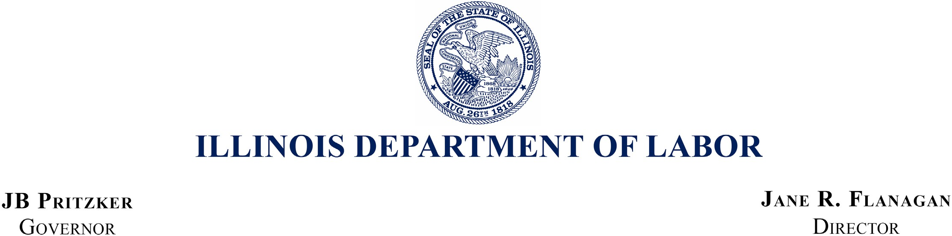

June 27, 2025

William J. Donovan, Regional Administrator

U.S. Department of Labor – OSHA 230 S. Dearborn Street, Room 3244

Chicago, IL 60604

Re: FY 2024 Federal Annual Monitoring and Evaluation Report

Dear Mr. Donovan:

Thank you for the opportunity to respond to the FY 2024 Follow-up Federal Annual Monitoring and Evaluation Report (FAME) for the Division of Occupational Safety and Health (IL OSHA). We are pleased to see that our sustained efforts have resulted in a FY 2024 FAME Report with no findings and no new observations.

IL OSHA will continue to address the observations identified in the report and remains dedicated to maintaining this level of performance.

If you have any questions regarding the FAME or anything else related to IL OSHA, please do not hesitate to contact IL OSHA Division Chief Erik Kambarian at 217-720-8079.

Very best regards,

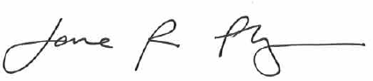

Jane R. Flanagan Director

ec: Suzanne M. Smith, Director of the Office of State Programs Aaron Priddy, Area Director, Fairview Heights, IL

|  |  |  |
| --- | --- | --- |
| Lincoln Tower Plaza | Michael A Bilandic Building | Regional Office Building |
| 524 South 2nd Street, Suite 400 | 160 North LaSalle, Suite C-1300 | 2309 West Main Street, Suite 115 |
| Springfield, Illinois 62701 | Chicago, Illinois 60601-3150 | Marion, Illinois 62959 |
| (217) 782-6206 | (312) 793-2800 | (618) 993-7090 |
| Fax: (217) 782-0596 | Fax: (312) 793-5257 | Fax: (618) 993-7258 |