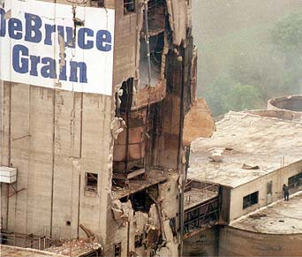
Combustible Dust Awareness Quick Guide

Kirkwood Community College

Funded by a Susan Harwood Grant
Disclaimer: This material was produced under grant number SH-17797-08-60-F-9 from the Occupational Safety and Health Administration, U.S. Department of Labor. It does not necessarily reflect the views or policies of the U.S. Department of Labor, nor does mention of trade names, commercial products, or organizations imply endorsement by the U.S. Government.

What is a Dust Explosion?
A dust explosion occurs when combustible dust is suspended in air and ignited. This causes very rapid burning with a release of gaseous products and subsequent pressure rise. The resulting explosive force can damage plant, property, and people. Dust explosions can be categorized as either primary or secondary

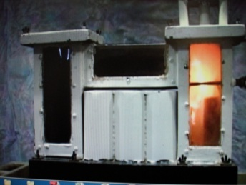
Primary Explosion
A primary explosion takes place in a confined atmosphere such as a cyclone, storage silo, or enclosed part of the manufacturing plant. After detonation, the shock wave can damage and often rupture walls, allowing burning dust and gases from the explosion to be expelled into the surrounding area.

Secondary Explosion
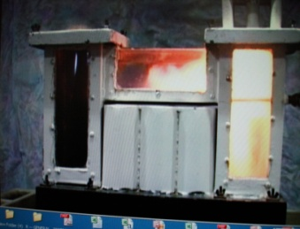
The primary explosion will disturb settled dust that may have accumulated. Once airborne, this dust can support a larger explosion; this is referred to as a secondary explosion. Secondary explosions can cause severe damage to surrounding plant buildings. All large-scale dust explosions result from chain reactions of this type. There may be a chain reaction of many explosions caused by the initial explosion

Required Conditions
For a dust explosion to take place, several key conditions must be present:
- The dust must be combustible.
- The dust cloud must be in the Minimum Explosive Concentration (MEC) for that particular dust.
- There must be sufficient oxygen in the atmosphere to support and sustain combustion.
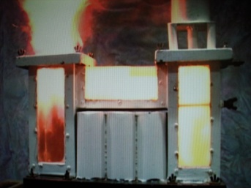
- The dust must be dry.
- The dust must be confined.
- There must be a source of ignition

Explosion Safeguards
Safeguards need to be activated to control the chances of a dust explosion. These safeguards are prevention, housekeeping dust control, eliminating fugitive dust (dust leaking from other sources), keeping the environment clean, and eliminating as many hazards as possible. Continuous housekeeping and sanitation and regularly scheduled bearing service should be top priorities at all grain elevators and flour and feed mills.
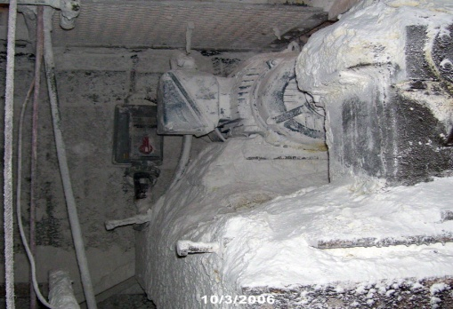
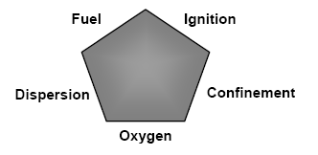

Explosion Pentagon

Many insurance companies insist on strict housekeeping, sanitation, and preventive maintenance at insured elevators. Grain, broken kernels, and grain dust accumulate in the leg boots and should be cleaned out periodically. Some elevators install easily removable doors on leg boot side panels for quick, easy cleanout.
Fires represent a major concern for many industries, including grain and feed mills, and result from many different causes. The end result of a fire, however, is always the same: personal injury, death, or loss of property.
The first and most important step in fire prevention is establishing a program to prevent fires from starting. This is particularly important in the feed and grain industries because of the potential for explosions and the track record of this industry for fires. A comprehensive fire prevention program not only addresses housekeeping issues, but also addresses all work activities in which the conditions for starting a fire are present such as hot work, electrical machinery, belts and drives, and grain dryers.
Recognizing Dust Hazards
All employees should be trained in hazard recognition.
- Conduct general facility-wide appraisals of dust explosion possibilities on a periodic basis.
- Conduct internal and external audits in order to identify potential explosion hazards.
- Encourage a preventative attitude among employees for eliminating dust explosions.
- Have employees and supervisors identify explosion hazards through job hazard analyses (JHAs).

Dust Control Methods
Methods for controlling grain dust accumulations include the following:
- Vacuum areas where dust accumulation is constant due to the job task being performed
- Wash down procedures where hoses and water can be used to remove accumulated dust.
- Choke feeds to control the flow of grain and grain dust.
- Dust control systems such as filters or cyclones.

¹ Kaulfersch, Joseph A., Preventing Dust Explosions. Control Engineering, January 11, 2007.

